# Module 2 - Assignment 2

## Kiser, Stephen

### Introduction to R Markdown

This is my first R markdown document. I will be covering atomic vectors, data frames, and data types. This was done in the first module, however it was done in a script file.

The next code seen will bring up a plot of sales over the past 6 months. This will be done using a new chunk of R data. First I will need to download tidyverse to use the function that creates plots.

library(tidyverse)

## -- Attaching packages ------------------------------- tidyverse 1.3.0 --

## v ggplot2 3.3.0 v purrr 0.3.3  
## v tibble 2.1.3 v dplyr 0.8.5  
## v tidyr 1.0.2 v stringr 1.4.0  
## v readr 1.3.1 v forcats 0.5.0

## -- Conflicts ---------------------------------- tidyverse_conflicts() --  
## x dplyr::filter() masks stats::filter()  
## x dplyr::lag() masks stats::lag()

sales <- c(50,150,200,100,300,250)  
month <- c(1,2,3,4,5,6)  
qplot(month,sales)

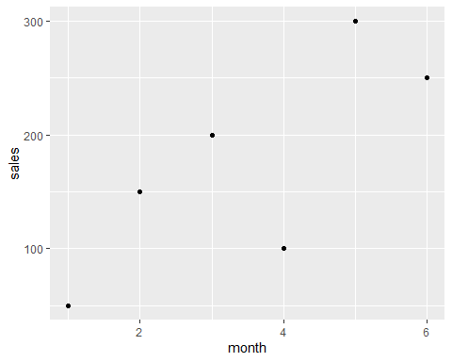

After creating the plot I wanted to see what month had the largest amount of sales. the 5th month, May, had the largest sales. In the fifth month there was 300 sales.

Yearly_Sales <- data.frame(month = c("Jan", "Feb", "Mar", "Apr", "May", "June", "July", "Aug", "Sep", "Oct", "Nov", "Dec"), sales = c(150.25, 258.54, 268.55, 122.52, 987, 458.82 , 667.23, 845.54, 586.78, 888.58, 756.12, 456.84))

After creating the data frame I wanted to see which months had the most sales and which month had the least sales. The month with the most sales was May with 987 sales. The month of April had the least amount ofsales with 122.52.